Assignment 2
Date Assigned: 09/07/2018
Due: Midnight 09/14/2018 on iLearn
Please read turn-in checklist at the end of this document before you start doing exercises.
Section 1: Pen-and-paper Exercises
- Arrange the following functions in ascending order of growth rate (7 points):
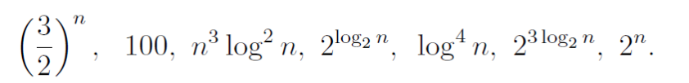
You are NOT required to justify your ordering.
Note:
In this problem, you are asked to identify if f1(n) < f2(n) for a “sufficiently large” input size n. However, for small values of n this is not always true.

Note: Since we did not finish the discussion of comparison, we will work on this problem in Assignment 3.

- Analyze the following code and provide a "Big-O" estimate of its running time in terms of n. Explain your analysis.
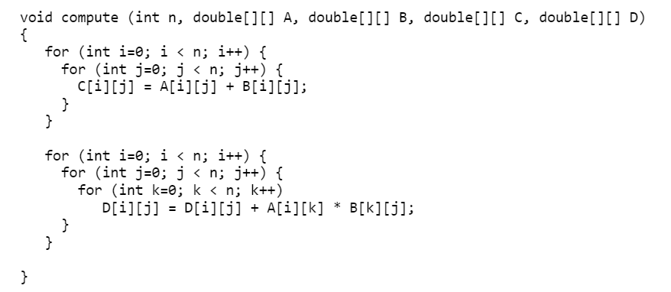
Note: Credit will not be given only for answers - show all your work:
(5 points) steps you took to get your answer.
(5 points) your answer.

- Analyze the following code and provide a "Big-O" estimate of its running time in terms of n. Explain your analysis.

int j = 1, i = 0;
while (i < n)
{
i = i + j;
j++;
}
Hint: The loop variable ‘i’ is incremented by 1, 2, 3, 4, … until i becomes greater than or equal to n.
Note: Credit will not be given only for answers - show all your work:
(5 points) steps you took to get your answer.
(5 points) your answer.

TURN-IN CHECKLIST:

- Answers to Section 1 (.doc/.txt/.pdf), and to Section 2 (all your source Code (.java files)). Remember to include your name, the date, and the course number in comments near the beginning of your code/report.

- Create a folder and name it 'FirstName_LastName_assignment_1'. In the newly created folder copy and paste your files (.doc/.txt/.java files). Then compress the folder, and push it to iLearn.

